ACKNOWLEDGEMENTS

we wish to thank our master Trainer Donald john for providing complete learning on bigdata and hadoop and guiding us in accomplishing the objectives of our project.

The H1B is an employment-based, non-immigrant visa category for temporary foreign workers in the United States. For a foreign national to apply for H1B visa, an US employer must offer a job and petition for H1B visa with the US immigration department. This is the most common visa status applied for and held by international students once they complete college/ higher education (Masters, Ph.D.) and work in a full-time position.

We will be performing analysis on the H1B visa applicants between the years 2011-2016. After analyzing the data, we can derive the following facts.

1 a) Is the number of petitions with Data Engineer job title increasing over time?
import java.io.IOException;
import org.apache.hadoop.conf.Configuration;
import org.apache.hadoop.fs.FileSystem;
import org.apache.hadoop.fs.Path;
import org.apache.hadoop.io.IntWritable;
import org.apache.hadoop.io.LongWritable;
import org.apache.hadoop.io.NullWritable;
import org.apache.hadoop.io.Text;
import org.apache.hadoop.mapreduce.Job;
import org.apache.hadoop.mapreduce.Mapper;
import org.apache.hadoop.mapreduce.Reducer;
import org.apache.hadoop.mapreduce.lib.input.FileInputFormat;
import org.apache.hadoop.mapreduce.lib.output.FileOutputFormat;

public class OT {

public static class MyMapper extends Mapper<LongWritable, Text, Text, IntWritable>
{
Text myKey = new Text();
IntWritable one = new IntWritable(1);

@Override
protected void map(LongWritable key, Text value, Context context)throws IOException, InterruptedException
{
String[] record = value.toString().split("\t");

String job_title = record[4];

String year = record[7];

if(job_title.contains("DATA ENGINEER") && job_title != null)
{
myKey.set(year);

context.write(myKey, one);
}
}
}

public static class MyReducer extends Reducer<Text,IntWritable,Text,IntWritable>
{
protected void reduce(Text key,Iterable<IntWritable> value,Context context)throws IOException, InterruptedException {
int sum=0;
for(IntWritable val:value)
{
sum+=val.get();
}

context.write(key, new IntWritable(sum));

}
}
public static class GrowthMapper extends Mapper<LongWritable,Text,Text,Text>
{
public void map(LongWritable key, Text value, Context context) throws IOException, InterruptedException
{
context.write(new Text("common"),value);
}
}

public static class GrowthReducer extends Reducer<Text,Text,NullWritable,Text>
{

protected void reduce(Text key,Iterable<Text> value,Context context)throws IOException, InterruptedException {
int count2011 = 1;
int count2012 = 1;
int count2013 = 1;
int count2014 = 1;
int count2015 = 1;
int count2016 = 1;

double growthavg = 0.00;
for(Text v:value)
{
String[] val=v.toString().split("\t");

if (val[0].equals("2011"))
{
count2011 = Integer.parseInt(val[1]);
}
if (val[0].equals("2012"))
{
count2012 = Integer.parseInt(val[1]);
}
if (val[0].equals("2013"))
{
count2013 = Integer.parseInt(val[1]);
}
if (val[0].equals("2014"))
{
count2014 = Integer.parseInt(val[1]);
}
if (val[0].equals("2015"))
{
count2015 = Integer.parseInt(val[1]);
}
if (val[0].equals("2016"))
{
count2016 = Integer.parseInt(val[1]);
}
}
growthavg = ((((count2012-count2011)*100)/count2011) + (((count2013-count2012)*100)/count2012) + (((count2014-count2013)*100)/count2013) + (((count2015-count2014)*100)/count2014) + (((count2016-count2015)*100)/count2015))/5 ;

if (growthavg>0.00)
{
context.write(NullWritable.get(), new Text("The growth is positive : " + String.format("%f", growthavg)));

}
}

}

public static void main(String[] args) throws Exception {

Configuration conf = new Configuration();
Job job = Job.getInstance(conf," ");
job.setJarByClass(OT.class);

job.setMapperClass(MyMapper.class);
job.setReducerClass(MyReducer.class);

job.setMapOutputKeyClass(Text.class);
job.setMapOutputValueClass(IntWritable.class);

job.setOutputKeyClass(Text.class);
job.setOutputValueClass(IntWritable.class);

Path outputPath1 = new Path("FirstMapper");
FileInputFormat.addInputPath(job, new Path(args[0]));
FileOutputFormat.setOutputPath(job, outputPath1);
FileSystem.get(conf).delete(outputPath1, true);

job.waitForCompletion(true);

Job job2 = Job.getInstance(conf," ");
job2.setJarByClass(OT.class);

job2.setMapperClass(GrowthMapper.class);
job2.setReducerClass(GrowthReducer.class);
//job2.setNumReduceTasks(0);

job2.setMapOutputKeyClass(Text.class);
job2.setMapOutputValueClass(Text.class);

job2.setOutputKeyClass(NullWritable.class);
job2.setOutputValueClass(Text.class);

FileInputFormat.addInputPath(job2,outputPath1);
FileOutputFormat.setOutputPath(job2, new Path(args[1]));

System.exit(job2.waitForCompletion(true) ? 0 :1);
}
}

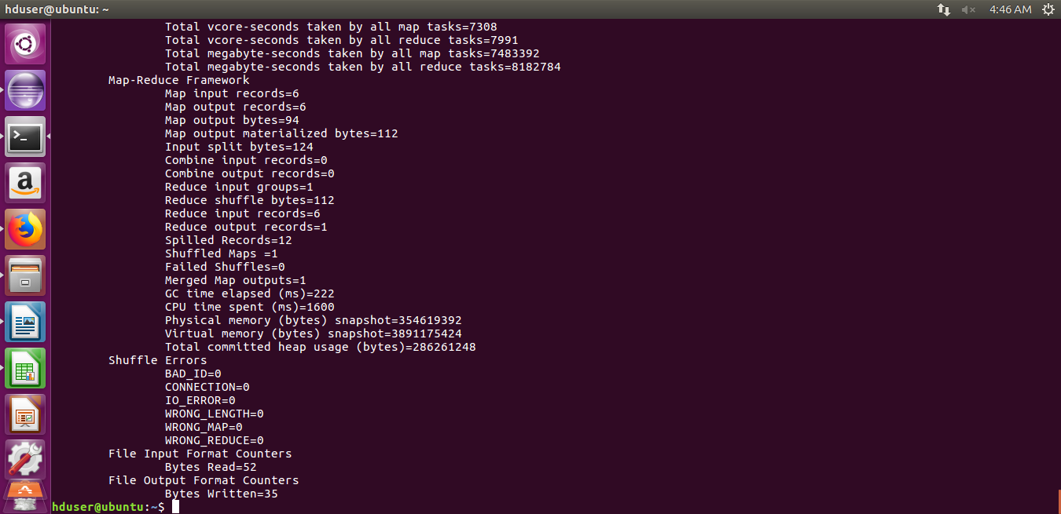
b) Find top 5 job titles who are having highest avg growth in applications.[ALL]
[no sub menu is required]

h1b = load '/home/hduser/Downloads/H1B' using PigStorage('\t') as (sno, casestatus, employername, socname, jobtitle:chararray, position, wage:double, year:chararray, lat, log);

h1bfilter = foreach h1b generate year,jobtitle;

year1 = filter h1bfilter by year == '2011';

--describe year1;

--year1: {year: chararray,jobtitle: chararray}

group1 = group year1 by jobtitle;

count1 = foreach group1 generate group, (DOUBLE)COUNT(year1.jobtitle);

year2 = filter h1bfilter by year == '2012';

group2 = group year2 by jobtitle;

count2 = foreach group2 generate group, (DOUBLE)COUNT(year2.jobtitle);

--describe count2;

join1 = join count1 by $0, count2 by $0;

growth1 = foreach join1 generate $0, $1, $3, (DOUBLE)((($3 - $1) * 100) / $1);

year3 = filter h1bfilter by year == '2013';

group3 = group year3 by jobtitle;

count3 = foreach group3 generate group, (DOUBLE)COUNT(year3.jobtitle);

join2 = join count2 by $0, count3 by $0;

growth2 = foreach join2 generate $0, $1, $3, (DOUBLE)((($3 - $1) * 100) / $1);

year4 = filter h1bfilter by year == '2014';

group4 = group year4 by jobtitle;

count4 = foreach group4 generate group, (DOUBLE)COUNT(year4.jobtitle);

join3 = join count3 by $0, count4 by $0;

growth3 = foreach join3 generate $0, $1, $3, (DOUBLE)((($3 - $1) * 100) / $1);

year5 = filter h1bfilter by year == '2015';

group5 = group year5 by jobtitle;

count5 = foreach group5 generate group, (DOUBLE)COUNT(year5.jobtitle);

join4 = join count4 by $0, count5 by $0;

growth4 = foreach join4 generate $0, $1, $3, (DOUBLE)((($3 - $1) * 100) / $1);

year6 = filter h1bfilter by year == '2016';

group6 = group year6 by jobtitle;

count6 = foreach group6 generate group, (DOUBLE)COUNT(year6.jobtitle);

--dump count6;

--describe count6;

--count6: {group: chararray,double}

join5 = join count5 by $0, count6 by $0;

growth5 = foreach join5 generate $0, $1, $3, (DOUBLE)((($3 - $1) * 100) / $1);

--dump growth5;

--describe growth5;

--join5: {count5::group: chararray,double,count6::group: chararray,double}

--growth5: {count5::group: chararray,double,double,double}

netjoin = join growth1 by $0, growth2 by $0, growth3 by $0, growth4 by $0, growth5 by $0;

--describe netjoin;

--netjoin: {join1::count1::group: chararray,double,join1::count2::group: chararray,double,join2::count2::group:
--chararray,double,join2::count3::group: chararray,double,join3::count3::group: chararray,double,join3::count4::group:
--chararray,double,join4::count4::group: chararray,double,join4::count5::group: chararray,double,join5::count5::group:
--chararray,double,join5::count6::group: chararray,double}

avggrowth = foreach netjoin generate $0, ($3+$7+$11+$15+$19) / 5;

--dump avggrowth;

--describe avggrowth;

--avggrowth: {join1::count1::group: chararray,double}

top5avg = limit (order avggrowth by $1 desc) 5;

dump top5avg;

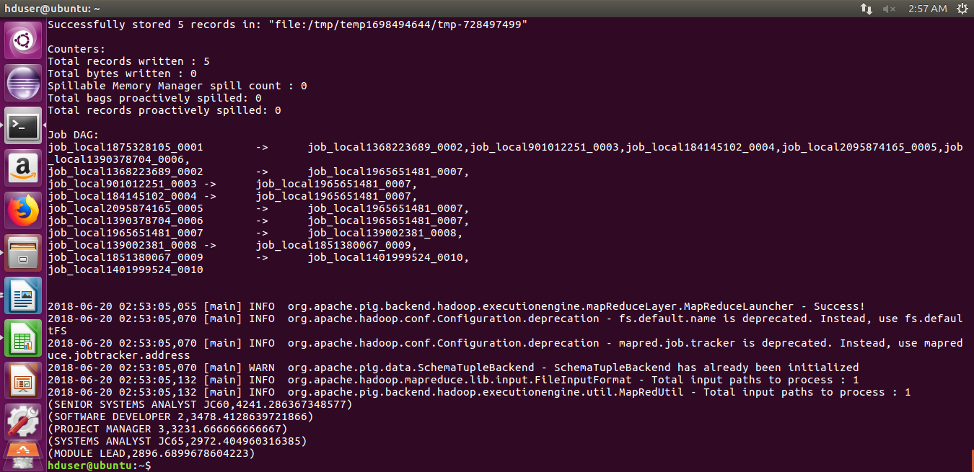
2a)Which part of the US has the most Data Engineer jobs for each year?
create table site as select COUNT(job_title) as most,job_title,worksite,year from h1b_final where job_title='DATA ENGINEER' group by job_title,worksite,year;

select * from site a where most in (select max(most) from site b where b.year=a.year) order by a.year;

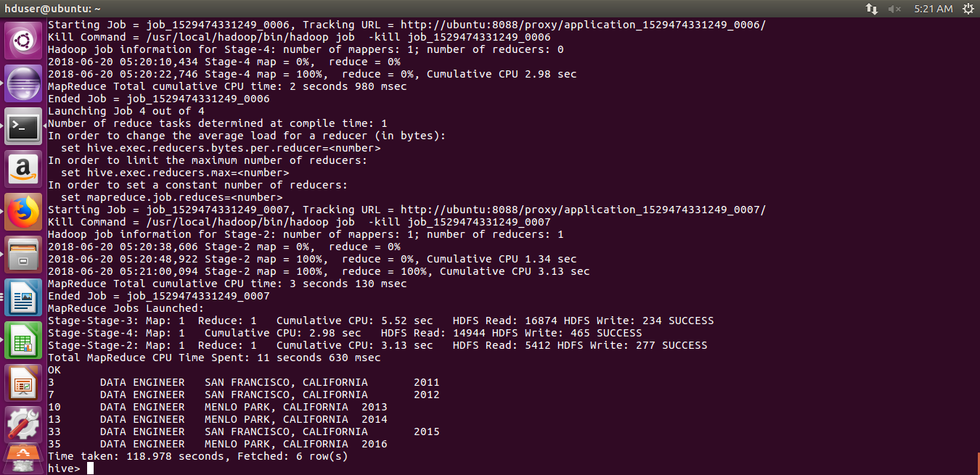
2b) find top 5 locations in the US who have got certified visa for each year.[certified]
[sub menu - year option is required]

PROGRAM:-
import java.io.*;

import org.apache.hadoop.io.*;
import org.apache.hadoop.io.LongWritable.DecreasingComparator;
import org.apache.hadoop.mapreduce.*;
import org.apache.hadoop.conf.*;
import org.apache.hadoop.fs.*;
import org.apache.hadoop.fs.FileSystem;
import org.apache.hadoop.mapreduce.Mapper.Context;
import org.apache.hadoop.mapreduce.lib.input.*;
import org.apache.hadoop.mapreduce.lib.output.*;

public class top5
{

public static class MapClass extends Mapper<LongWritable,Text,Text,Text>
{
public void map(LongWritable key, Text value, Context context)
{
try
{
String[] str = value.toString().split("\t");
if((str[1].toLowerCase()).equals("certified") && str[7].equals("2011"))
{
String job_case_yr = str[8];
String yrsite = str[7] + ";" + str[8];

context.write(new Text (job_case_yr),new Text (yrsite));

}
}
catch(Exception e)
{
System.out.println(e.getMessage());
}

}
}

public static class ReduceClass extends Reducer<Text,Text,LongWritable,Text>
{

private LongWritable result = new LongWritable();
private Text keyres = new Text();
long max = 0;
public void reduce(Text key, Iterable<Text> values,Context context) throws IOException, InterruptedException
{

long count11=0;
long count12=0;
long count13=0;
long count14=0;
long count15=0;
long count16=0;
String city = "";
String yrb[] = new String[2];

//String yrb[] = key.toString().split(";");

for (Text val : values)
{
String yr[] = val.toString().split(";");
yrb[0] = yr[0];
yrb[1] = yr[1];
//if(yr[0].equals("2011"))
count11 = count11 + 1;
//if(yr[0].equals("2012"))
//count12 = count12 + 1;
//if(yr[0].equals("2013"))
//count13 = count13 + 1;
//if(yr[0].equals("2014"))
//count14 = count14 + 1;
//if(yr[0].equals("2015"))
//count15 = count15 + 1;
// if(yr[0].equals("2016"))
// count16 = count16 + 1;

}
String redval = key + ";" + yrb[0];

//if(yrb[0].equals("2011"))
context.write(new LongWritable(count11), new Text(key));
//if(yrb[0].equals("2012"))
// context.write(new LongWritable(count12),key);
//if(yrb[0].equals("2013"))
//context.write(new LongWritable(count13),key);
//if(yrb[0].equals("2014"))
// context.write(new LongWritable(count11),new Text(redval));
//if(yrb[0].equals("2015"))
//context.write(new LongWritable(count11),new Text(redval));
//if(yrb[0].equals("2016"))
// context.write(new LongWritable(count11),new Text(redval));

}
}
public static class SortMapper extends Mapper<LongWritable,Text,LongWritable,Text>
{
public void map(LongWritable key, Text value, Context context) throws IOException, InterruptedException
{
String[] valueArr = value.toString().split("\t");
context.write(new LongWritable(Long.parseLong(valueArr[0])), new Text(valueArr[1]));
}
}

public static class SortReducer extends Reducer<LongWritable,Text,Text,LongWritable>
{
int counter = 0;
public void reduce(LongWritable key, Iterable<Text> value, Context context) throws IOException, InterruptedException
{

//counter = 0;
for(Text val : value)
{
if(counter < 5)

context.write(new Text(val), key);

counter++;
}

}
}

public static void main(String[] args) throws Exception {
Configuration conf = new Configuration();
//conf.set("name", "value")
//conf.set("mapreduce.input.fileinputformat.split.minsize", "134217728");
Job job = Job.getInstance(conf, "count");
job.setJarByClass(top5.class);
job.setMapperClass(MapClass.class);
//job.setCombinerClass(ReduceClass.class);
job.setReducerClass(ReduceClass.class);
//job.setNumReduceTasks(0);
job.setMapOutputKeyClass(Text.class);
job.setMapOutputValueClass(Text.class);
job.setInputFormatClass(TextInputFormat.class);

job.setOutputFormatClass(TextOutputFormat.class);
job.setOutputKeyClass(LongWritable.class);
job.setOutputValueClass(Text.class);
FileInputFormat.addInputPath(job, new Path(args[0]));
Path outputPath1 = new Path("FirstMapper");
FileOutputFormat.setOutputPath(job, outputPath1);
FileSystem.get(conf).delete(outputPath1, true);
job.waitForCompletion(true);

Job job3 = Job.getInstance(conf,"Per Occupation - totalTxn");
job3.setJarByClass(top5.class);
job3.setSortComparatorClass(DecreasingComparator.class);
job3.setMapperClass(SortMapper.class);
//job3.setPartitionerClass(CaderPartitioner.class);
job3.setReducerClass(SortReducer.class);
//job3.setNumReduceTasks(0);
job3.setSortComparatorClass(DecreasingComparator.class);
job3.setMapOutputKeyClass(LongWritable.class);
job3.setMapOutputValueClass(Text.class);
job3.setOutputKeyClass(Text.class);
job3.setOutputValueClass(LongWritable.class);
FileInputFormat.addInputPath(job3, outputPath1);
FileOutputFormat.setOutputPath(job3, new Path(args[1]));
System.exit(job3.waitForCompletion(true) ? 0 : 1);
}

}

OUTPUT
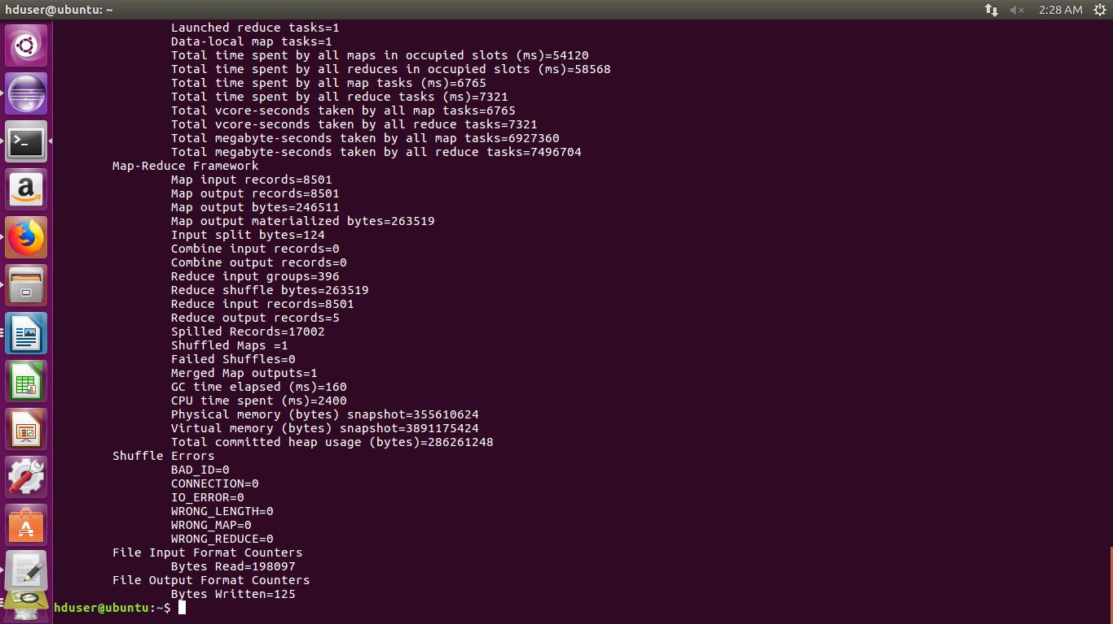
3)Which industry(SOC_NAME) has the most number of Data Scientist positions?
[certified]
[no sub menu is required]

PROGRAM:-
h1b2 = LOAD '/home/hduser/Downloads/H1B' USING PigStorage() AS (s_no, case_status:chararray, employer_name: chararray, soc_name: chararray, job_title:chararray, full_time_position:chararray,prevailing_wage:long,year:chararray, worksite:chararray, longitute: double, latitute: double );

top = foreach h1b2 generate job_title, year;

--dump top;

top11 = filter top by $1 == '2011';

--dump top11;

top11grpbyjob = GROUP top11 by $0;

--dump top11grpbyjob;

top11count = foreach top11grpbyjob generate group, (DOUBLE)COUNT(top11.year) AS tot;

--dump top11count;

top12 = filter top by $1 == '2012';

--dump top12;

top12grpbyjob = GROUP top12 by $0;

--dump top12grpbyjob;

top12count = foreach top12grpbyjob generate group, (DOUBLE)COUNT(top12.year) AS tot;

--dump top12count;

top1112join = join top11count by $0, top12count by $0;

--dump top1112join;

top1112cal = foreach top1112join generate $0, $1,$3, (DOUBLE)((($3-$1)*100)/$1);

--dump top1112cal;

top13 = filter top by $1 == '2013';
top13grpbyjob = GROUP top13 by $0;
top13count = foreach top13grpbyjob generate group, (DOUBLE)COUNT(top13.year) AS tot;

top1213join = join top12count by $0, top13count by $0;
top1213cal = foreach top1213join generate $0, $1,$3, (DOUBLE)((($3-$1)*100)/$1);

top14 = filter top by $1 == '2014';
top14grpbyjob = GROUP top14 by $0;
top14count = foreach top14grpbyjob generate group, (DOUBLE)COUNT(top14.year) AS tot;

top1314join = join top13count by $0, top14count by $0;
top1314cal = foreach top1314join generate $0, $1,$3, (DOUBLE)((($3-$1)*100)/$1);

top15 = filter top by $1 == '2015';
top15grpbyjob = GROUP top15 by $0;
top15count = foreach top15grpbyjob generate group, (DOUBLE)COUNT(top15.year) AS tot;

top1415join = join top14count by $0, top15count by $0;
top1415cal = foreach top1415join generate $0, $1,$3, (DOUBLE)((($3-$1)*100)/$1);

top16 = filter top by $1 == '2016';
top16grpbyjob = GROUP top16 by $0;
top16count = foreach top16grpbyjob generate group, (DOUBLE)COUNT(top16.year) AS tot;

top1516join = join top15count by $0, top16count by $0;
top1516cal = foreach top1516join generate $0, $1,$3, (DOUBLE)((($3-$1)*100)/$1);

finjoin = join top1112cal by $0, top1213cal by $0, top1314cal by $0, top1415cal by $0, top1516cal by $0;

fingen = foreach finjoin generate $0, (DOUBLE)(($3+$7+$11+$15+$19)/5);
finlim = limit (order fingen BY $1 desc) 5;

dump finlim;

OUTPUT:-

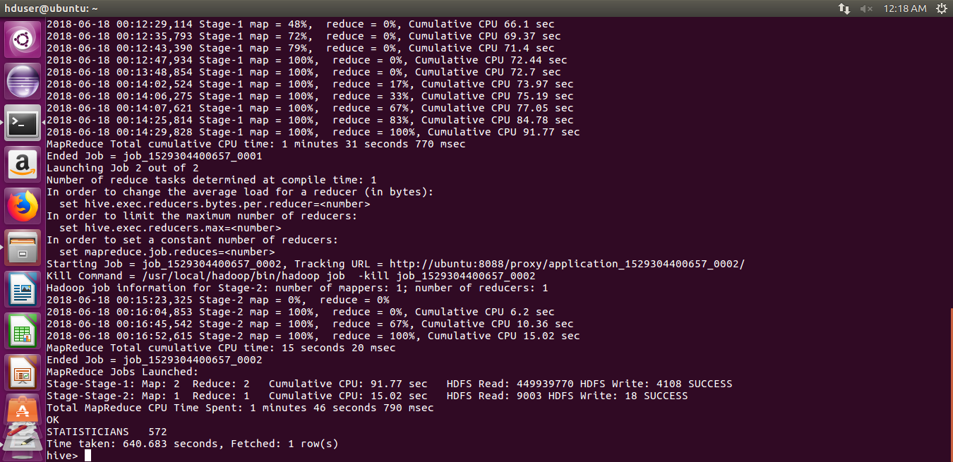
4)Which top 5 employers file the most petitions each year? - Case Status - ALL
[sub menu - year option is required]

PROGRAM:-

select employer_name, count(*) as total from H1B.h1b_final where year = $year group by employer_name order by total desc limit 5;

OUTPUT:-

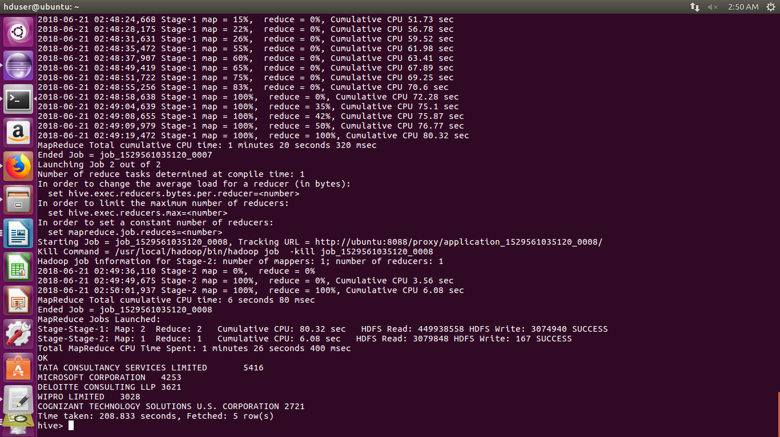
5) Find the most popular top 10 job positions for H1B visa applications for each year?
a) for all the applications
b) for only certified applications.
[second sub menu - year option is required]

PROGRAM:-
select year, job_title, count(*) as job from H1b_final where year=2011group by year, job_title order by job desc limit 10;

OUTPUT:-

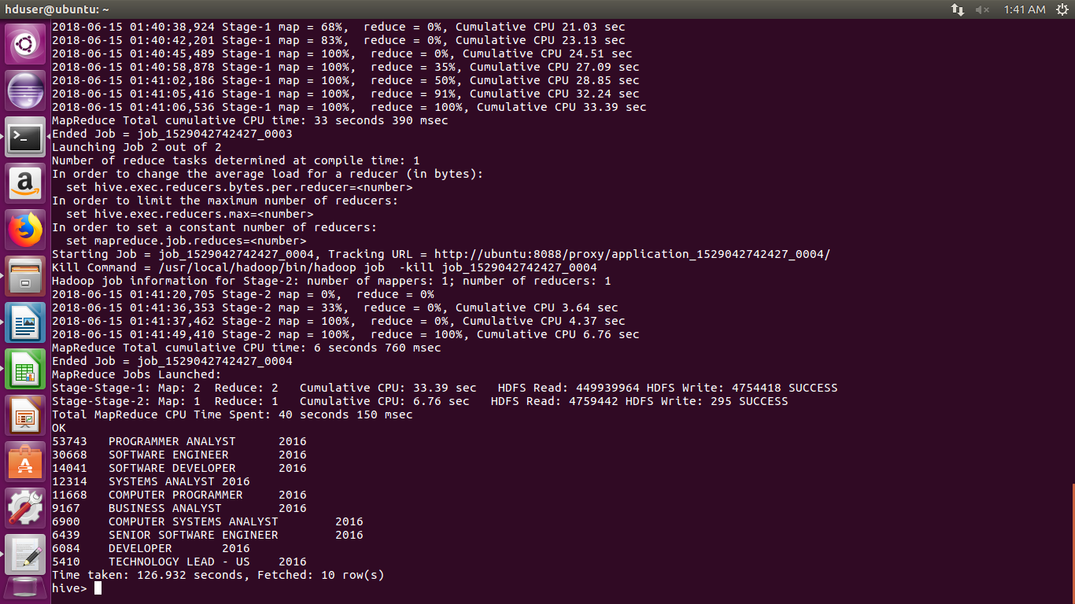
5b)
PROGRAM:-
select year, job_title, count(*) as job from H1b.h1b_final where year=’2011’ and lower(case_status)=’certified’ group by year, job_title order by job desc limit 10;
OUTPUT:-

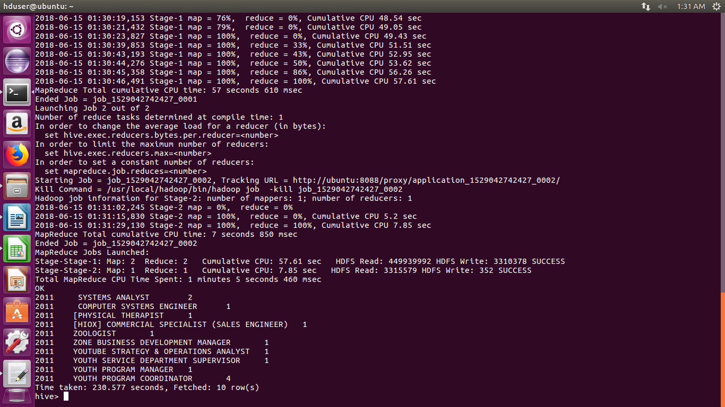
6) Find the percentage and the count of each case status on total applications for each year. Create a line graph depicting the pattern of All the cases over the period of time.
[no sub menu is required]

program:-

h1b = LOAD '/home/hduser/Downloads/H1B' USING PigStorage() AS (s_no, case_status:chararray, employer_name: chararray, soc_name: chararray, job_title:chararray, full_time_position:chararray,prevailing_wage:long,year:chararray, worksite:chararray, lon,lat);

sixgen = foreach h1b generate case_status,year;

--dump sixgen;

sixgengrp = GROUP sixgen all;

--dump sixgengrp;

sixcount = foreach sixgengrp generate COUNT(sixgen.case_status), COUNT(sixgen.case_status) - COUNT(sixgen.case_status);

--dump sixcount;

sixyr12 = filter sixgen by $1 == '2012';

--dump sixyr12;

six12grp = GROUP sixyr12 by case_status;

--dump six12grp;

six12count = foreach six12grp generate group, COUNT(sixyr12.year), COUNT(sixyr12.year) - COUNT(sixyr12.year);

--dump six12count;

six12join = join six12count by $2, sixcount by $1;

--dump six12join;

six12percent = foreach six12join generate $0, (DOUBLE)$1, (DOUBLE)$3;

--dump six12percent;

six12pergen = foreach six12percent generate $0, $1, $2, (DOUBLE)(($1*100)/$2);

dump six12pergen;

OUTPUT:-

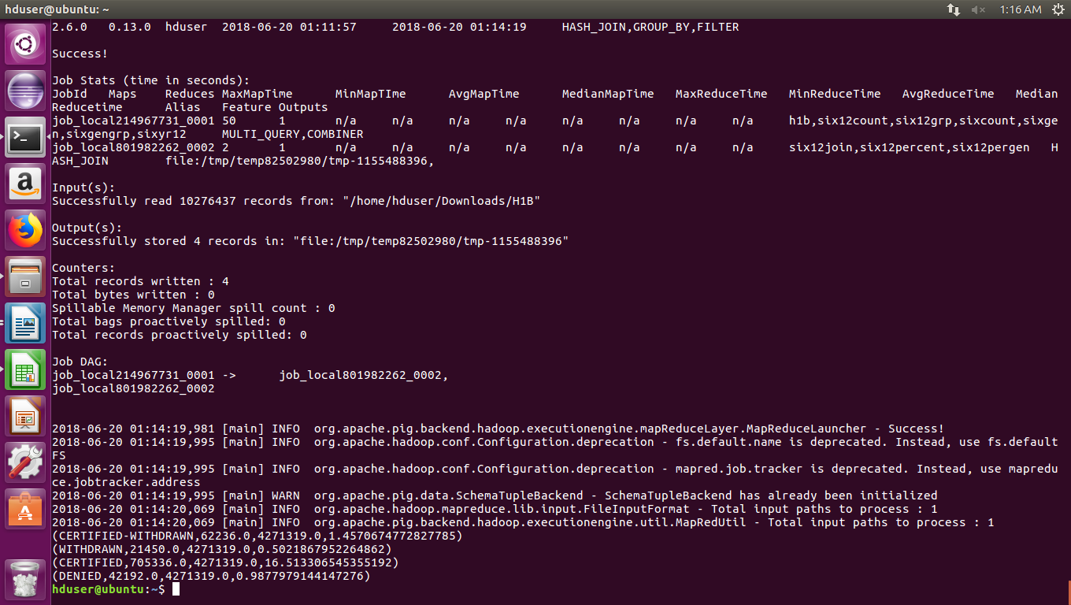
7) Create a bar graph to depict the number of applications for each year [All]
[no sub menu is required]
import java.io.*;

import org.apache.hadoop.io.DoubleWritable;
import org.apache.hadoop.io.Text;
import org.apache.hadoop.io.LongWritable;
import org.apache.hadoop.mapreduce.Job;
import org.apache.hadoop.mapreduce.Mapper;
import org.apache.hadoop.mapreduce.Reducer;
import org.apache.hadoop.conf.*;
import org.apache.hadoop.fs.*;
import org.apache.hadoop.mapreduce.Reducer.Context;
import org.apache.hadoop.mapreduce.lib.input.*;
import org.apache.hadoop.mapreduce.lib.output.*;

public class Applications
{

public static class MapClass extends Mapper<LongWritable,Text,LongWritable,Text>
{

public void map(LongWritable key, Text value, Context context)
{
try{
String[] str = value.toString().split("\t");
long year = Long.parseLong(str[7]);
context.write(new LongWritable(year),new Text(str[0]));
}
catch(Exception e)
{
System.out.println(e.getMessage());
}
}
}

public static class ReduceClass extends Reducer<LongWritable,Text,LongWritable,LongWritable>
{
private LongWritable result = new LongWritable();

public void reduce(LongWritable key, Iterable<Text> values,Context context) throws IOException, InterruptedException

{
long count=0;
long yr = Long.parseLong(key.toString());
for (Text val : values)
{
if(val != null)
{
count = count + 1;
}

}
result.set(count);
context.write(key,result);

}
}

public static void main(String[] args) throws Exception {
Configuration conf = new Configuration();
//conf.set("name", "value")
//conf.set("mapreduce.input.fileinputformat.split.minsize", "134217728");
Job job = Job.getInstance(conf, "count");
job.setJarByClass(Applications.class);
job.setMapperClass(MapClass.class);
//job.setCombinerClass(ReduceClass.class);
job.setReducerClass(ReduceClass.class);
// job.setNumReduceTasks(0);
job.setMapOutputKeyClass(LongWritable.class);
job.setMapOutputValueClass(Text.class);
job.setOutputKeyClass(LongWritable.class);
job.setOutputValueClass(LongWritable.class);
FileInputFormat.addInputPath(job, new Path(args[0]));
FileOutputFormat.setOutputPath(job, new Path(args[1]));
System.exit(job.waitForCompletion(true) ? 0 : 1);
}

}
OUTPUT:-

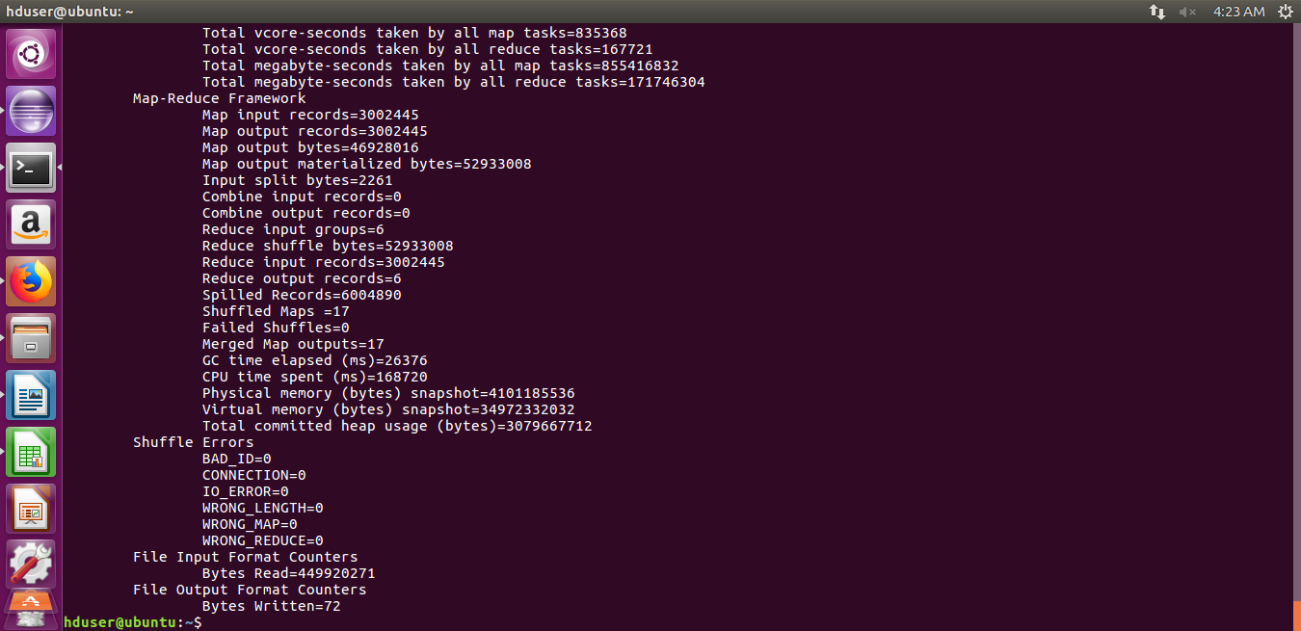
GRAPH:-
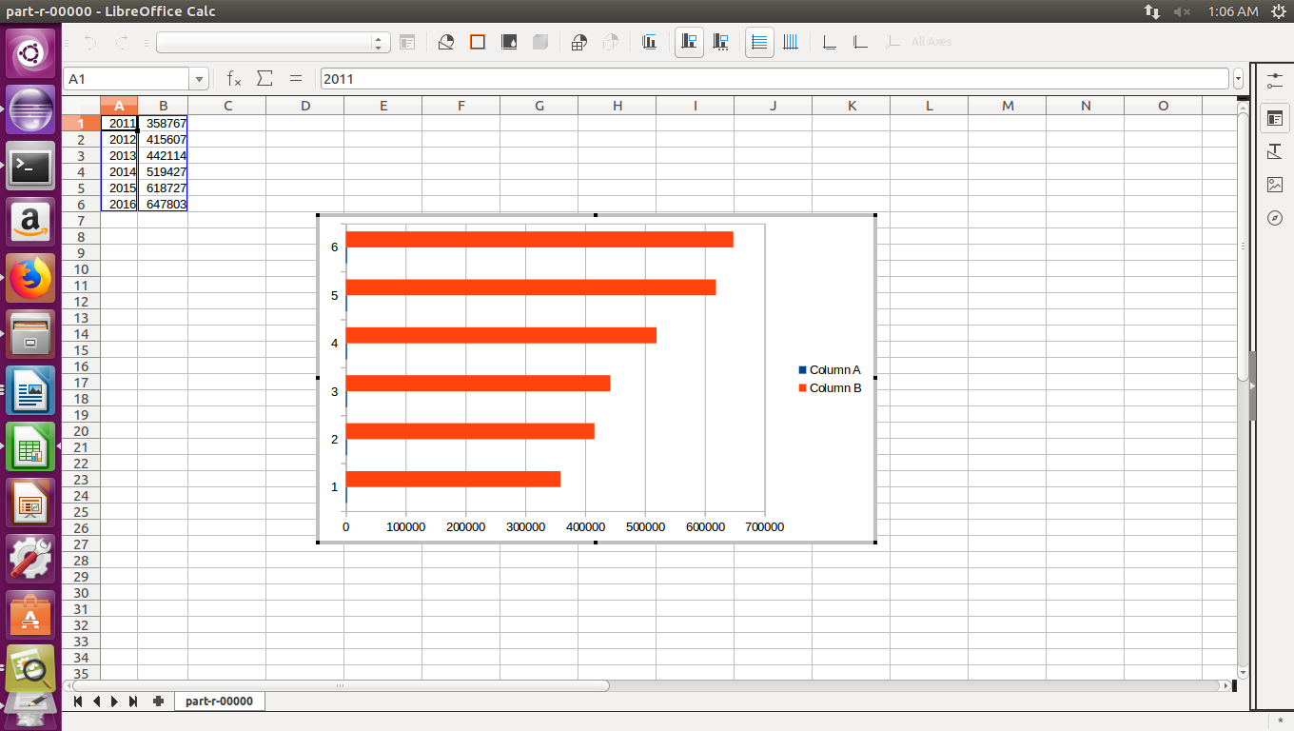

8) Find the average Prevailing Wage for each Job for each Year (take part time and full time separate). Arrange the output in descending order - [Certified and Certified Withdrawn.] [Top 20 only required]
[first sub menu - full time OR part time]
[second sub menu - year option is required]

PROGRAM:-
h1b = load '/home/hduser/Downloads/H1B' using PigStorage('\t') as (sno, casestatus:chararray, employername, socname, jobtitle:chararray, position:chararray, wage:double, year:chararray, lat, log);

--h1b10 = limit h1b 10;

--dump h1b10;

h1bfilter = foreach h1b generate casestatus, jobtitle, position, wage, year;

--h1bfilter10 = limit h1bfilter 10;

--dump h1bfilter10;

csfilter = filter h1bfilter by LOWER(casestatus) == 'certified' OR LOWER(casestatus) == 'certified-withdrawn';

--csfilter20 = limit csfilter 20;

--dump csfilter20;

parttime = filter csfilter by LOWER(position) == 'n';

--parttime5 = limit parttime 5;

--dump parttime5;

partbyboth = group parttime by (year,jobtitle);

--partbyboth5 = limit partbyboth 5;

--dump partbyboth5;

partbysum = foreach partbyboth generate FLATTEN(group) as (year,jobtitle), parttime.casestatus, parttime.position, SUM(parttime.wage) as sum, COUNT(parttime.wage) as count;

--partbysum10 = limit partbysum 10;

--dump partbysum10;

partbyavg = foreach partbysum generate $0, $1, ROUND_TO((DOUBLE)($4 / $5),2) as average;

yearavg = filter partbyavg by $0 == '2011';

byorder = order yearavg by $2 desc;

byorder10 = limit byorder 20;

dump byorder10;

describe byorder;

OUTPUT:-

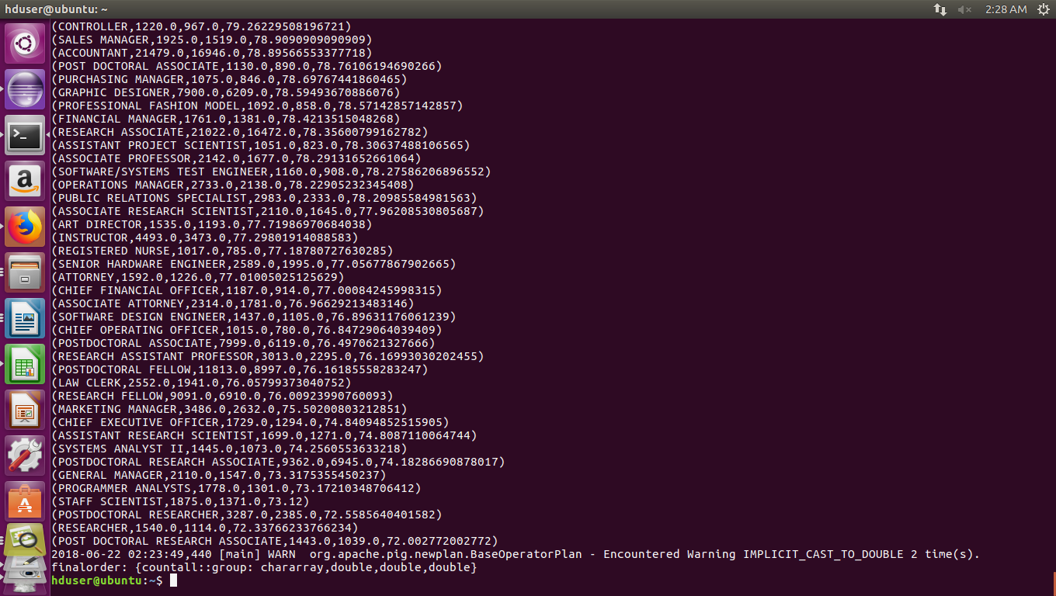

9) Which are the employers along with the number of petitions who have the success rate more than 70% in petitions. (total petitions filed 1000 OR more than 1000) ? Display the values in descending order of success rate.
[no sub menu is required]

PROGRAM:-

h1b = load '/home/hduser/Downloads/H1B' using PigStorage('\t') as (sno, casestatus:chararray, employername:chararray, socname, jobtitle, position, wage, year, lat, log);

--h1b10 = h1b limit 10;

--dump h1b10;

h1bfilter = foreach h1b generate employername, casestatus;

group1 = group h1bfilter by employername;

countall = foreach group1 generate group, (DOUBLE)COUNT(h1bfilter.casestatus);

csfilter = filter h1bfilter by LOWER(casestatus) == 'certified' OR LOWER(casestatus) == 'certified withdrawn';

group2 = group csfilter by employername;

countboth = foreach group2 generate group, (DOUBLE)COUNT(csfilter.casestatus);

netjoin = join countall by $0, countboth by $0;

success = foreach netjoin generate $0, $1, $3, (($3 * 100) / $1);

final = filter success by $3 > 70.00 AND $1 >= 1000;

finalorder = order final by $3 desc;

dump finalorder;

describe finalorder;

--finalorder: {countall::group: chararray,double,double,double}

OUTPUT:-

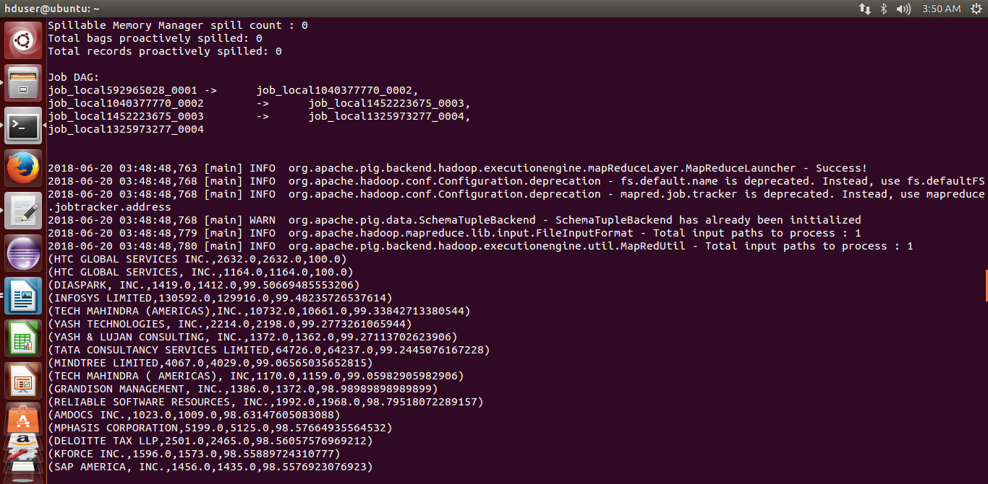
10) Which are the job positions along with the number of petitions which have the success rate more than 70% in petitions (total petitions filed 1000 OR more than 1000)? Display the values in descending order of success rate.
[no sub menu is required]

PROGRAM:-
h1b = load '/home/hduser/Downloads/H1B' using PigStorage('\t') as (sno, casestatus:chararray, employername, socname, jobtitle:chararray, position, wage, year, lat, log);

--h1b10 = h1b limit 10;

--dump h1b10;

h1bfilter = foreach h1b generate jobtitle, casestatus;

group1 = group h1bfilter by jobtitle;

countall = foreach group1 generate group, (DOUBLE)COUNT(h1bfilter.casestatus);

csfilter = filter h1bfilter by LOWER(casestatus) == 'certified' OR LOWER(casestatus) == 'certified withdrawn';

group2 = group csfilter by jobtitle;

countboth = foreach group2 generate group, (DOUBLE)COUNT(csfilter.casestatus);

netjoin = join countall by $0, countboth by $0;

success = foreach netjoin generate $0, $1, $3, (($3 * 100) / $1);

final = filter success by $3 > 70.00 AND $1 >= 1000;

finalorder = order final by $3 desc;

dump finalorder;

describe finalorder;

--finalorder: {countall::group: chararray,double,double,double}

OUTPUT:-

